Prescribing Tip For Information
2023 High Strength Opioid Audit Results – GP and CSR SICBL
There is no evidence for efficacy of high dose opioids (>120mg/day morphine equivalent) in chronic non-cancer pain. The Faculty of Pain Medicine (FPM) has advised that increasing opioid load above this dose is unlikely to yield further benefits but exposes the patient to increased harm.
Since 2017, the Medicines Optimisation Team (MOT) has worked with colleagues to bring prescribing into line with evidence-based recommendations. A baseline audit in 2017 determined the number of patients prescribed high dose opioids >120mg/day morphine equivalent. Education and training sessions were provided alongside individual medication reviews. Re-audit occurred in 2021 and in 2023.
Overall reduction in number of patients taking > 120mg/day morphine equivalent across 47 practices in Greater Preston SICBL and Chorley and South Ribble SICBL from Aug-17 to Sep-23 = 371 patients (reduction from 580pts to 209pts) =
64% reduction*
Impact

The Medicines Optimisation Team would like to thank all the clinical and administration staff working across GP and CSR SICBLs for their tireless efforts over the past 6 years in reducing the numbers of patients taking these harmful doses of opioids.

A special mention goes to the following 4 practices who have managed to achieve the gold standard of having ZERO patients prescribed >120mg/day morphine equivalent.
Dr Ali, Guttridge Medical Centre | The New Hall Lane Practice
St Fillan’s Medical Centre | Station Surgery

A further 8 practices are close to achieving the gold standard, having a SINGLE patient prescribed >120mg/day morphine equivalent.
Avenham Surgery | Lane Ends Surgery | Ribble Village HC | Dr Yerra, Guttridge MC
Clayton Brook Surgery | New Longton Surgery | Dr Dawoud’s Surgery | The Village Surgeries
All practices in GP & CSR can learn more about their individual audit results by contacting your Medicines Optimisation Team pharmacist or technician.
*Following the 2021 audit the FPM aligned its opioid dose equivalencies to less conservative equivalencies within the BNF. As 2023 was the first audit to use these less conservative equivalencies, the reduction in patient numbers seen between 2021-2023 is in large part due to this change. If this change had not occurred, then patient numbers would have decreased by 21 in GP SICBL and increased by 14 in CSR SICBL. This indicates that some HCPs are continuing to escalate doses above the recommended maximum of 120mg/day morphine equivalent.
Prescribing Tip For Information

2023 High Strength Opioid Audit Results – West Lancashire SICBL
Due to ICB restructuring, in 2023 the Central Lancashire Medicines Optimisation Team also audited 12 practices in West Lancashire SICBL for the first time. This baseline audit determined the number of patients prescribed high dose opioids >120mg/day morphine equivalent across West Lancashire at a practice level. A total of 108 patients were found to be prescribed >120mg/day morphine equivalent.
Total number of patients identified as taking > 120mg/day morphine equivalent
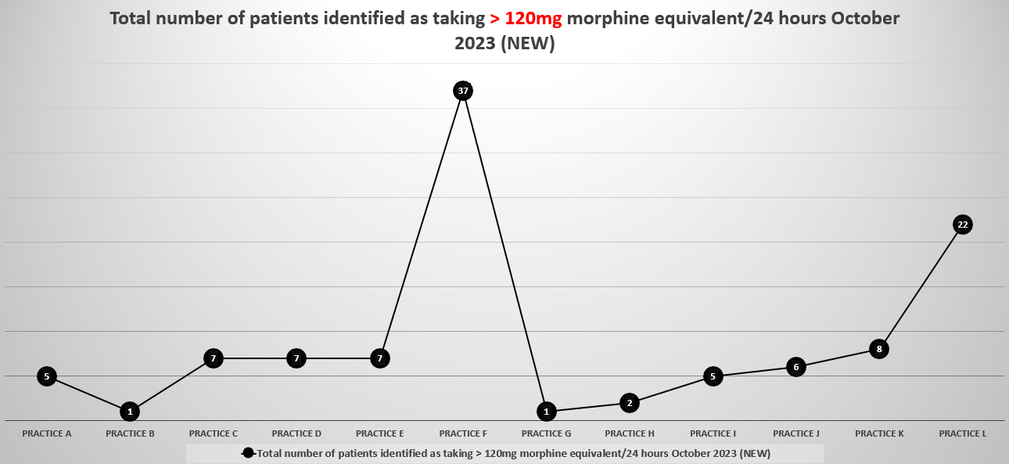
Total number of patients identified as taking > 120mg/day morphine equivalent PER 1000 patients
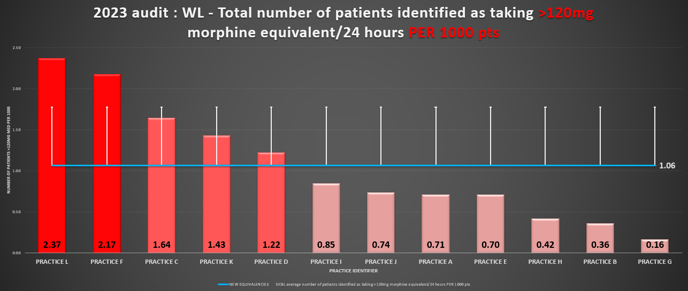
A special mention goes to 2 practices who are close to achieving the gold standard, having a SINGLE patient prescribed >120mg/day morphine equivalent.
Burscough Family Practice | Aughton Surgery
All 12 audited practices in WL can learn more about their individual audit results by contacting your Medicines Optimisation Team pharmacist or technician.
To contact the Medicines Optimisation Team please phone 01772 214302
If you have any suggestions for future topics to cover in our prescribing tips, please contact Nicola.schaffel@nhs.net
All content accurate and correct on the date of issue of this tip.

